Harmonic Analyse

Introduction:

In acoustics the harmonic of a wave is a component frequency of the signal that is an integer multiple of the fundamental frequency. For example, if the frequency is f, the harmonics have frequency 2f, 3f, 4f, etc, as well as f itself. The harmonics have the property that they are all periodic at the signal frequency as can be seen in the spectrum of test signal above. Also, due to the properties of Fourier series, the sum of the signal and its harmonics is also periodic at that frequency.

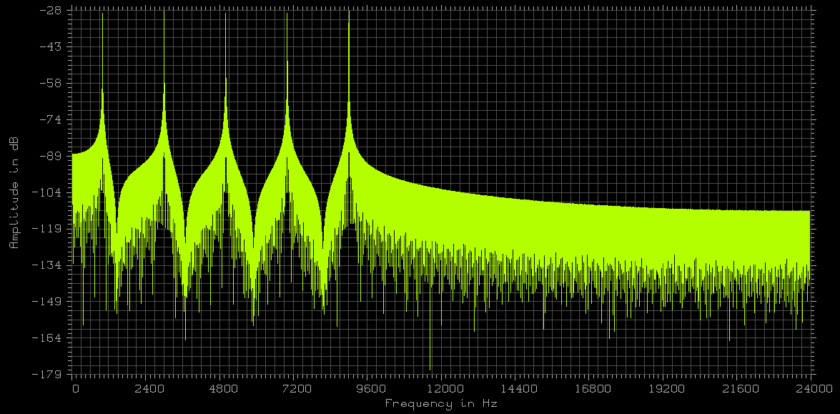

Algorithm:

Our implementation tries to find first the fundamental frequency in a given frequency range and to extracts the level and the frequency of the fundamental. Based on this fundamental, the harmonic analyse try to find the level of the harmonics which are multiples of the fundamental frequency. Two methods are implemented to find the harmonics.
- Exaxt Position Method:
The easiest way to find the harmonics is to extract the levels of multiplers of the fundamental frequency. This method has the disadvantage that the frequency of the harmonics often do not exactly match the calculated frequency. To prevent this error the following method was developed.
- Search Intervall Method:
The search interval method searches the highest peak around the predicted harmonic for a given interval size. The size of the search interval will be adopted for each harmonic and can be specified in the function signature. The default value for the search is 0.5 percent which means that for the second harmonic the peak will be searched around 1 percent of whole signal, for the third harmonic the peak will be searched around 2 percent and so on. The function caller has to be take care that the search radius is not bigger that the distance of the harmonics itself.

The function works full autonomous and does need the time domain based signal, the length of the signal, the sample rate to extract the Nyquist-Frequency, the search radius for the harmonics in percent and the band borders for the fundamental frequency. As following the function signature:

harmonicAnalyse(double* signal, int length, int sampleRate, double lowerSearchFrequency, double upperSearchFrequency, double* fundamenalFrequency, double* fundamentalFrequencyLevel, int extraction_method = EXACT_POSITION, double searchRadius = .5);

The function returns the found fundamental frequency, the level of the fundamental frequency and the level of the first ten harmonics.

Implemenation:

The whole time domain signal will be transformed into the frequency domain and all following processing operates on the logarithm of this power spectrum. Following shown the header file of the algorithm with the function signature. Like all other mathematical classes the function is implemented as static procedure so no instanciation of the core class is neccesarry. The implementation details can be found into the C++ implementation source file.
00001 /**
00002 * (c) RTE Akustik + Prüftechnik GmbH
00003 *
00004 * @file hatrminic_analyse.h
00005 * @class Harmonic Analyse
00006 * @version 1.0
00007 * @date 2014
00008 * @author Christoph Lauer
00009 * @brief Collects functions for the harmonic analyse
00010 * @see http://en.wikipedia.org/wiki/Harmonic
00011 * @todo finished so far
00012 */
00013
00014 //------------------------------------------------------------------------------------------------
00015
00016 #ifndef RTE_MATH_HARMONIC_ANALYSE
00017 #define RTE_MATH_HARMONIC_ANALYSE
00018
00019 //------------------------------------------------------------------------------------------------
00020
00021 namespace rte
00022 {
00023 namespace math
00024 {
00025
00026 //------------------------------------------------------------------------------------------------
00027
00028 /**
00029 * This class implements functions for the harmonic analyse. Like all other mathematical classes this
00030 * class collects static functions. THe harmonic analyse function trys to find a fundamental frequency
00031 * in a given search intervall and extracts the levels of the harmonic followers. The resulting return
00032 * values are all in dB level dimensions appart from the frequency return values.
00033 */
00034 class HarmonicAnalyse
00035 {
00036
00037 public:
00038
00039 /**
00040 * This enummeration defines the harmonics search method. Two methods are implemented.
00041 * The first (EXACT_POSITION) method looks for the peak at the exact multipler possitions of the ground frequency.
00042 * The second method (SEARCH_IN_INTERVALL) searches the harmonics based on the fundamental frequency arround an
00043 intervall
00044 * border. The border is typically determined by an percent value of the first fundamental frequency.
00045 * In this case the search border will be determined by percentage value of the fundamental frequency
00046 * which is the applyed to search for the harmonics with a multipler of the harmoc frequencies.
00047 * Example given: If the fundamental was found at 100Hz and the search border was predefined at 1%,
00048 * for the second order harmonics the search intervall was +/-1 percent, from 199...200Hz. For the
00049 * third oder harmonic the intervall was at +/-3Hz, from 297...306 and so on.
00050 */
00051 enum extraction_method{EXACT_POSITION, SEARCH_IN_INTERVALL};
00052
00053 /**
00054 * This function performs an harmonic analyse. Given the Signal, the length, the sample rate and
00055 * the search intervall for the first harmonic this function try to find the peak in the search
00056 * intervall and looks for the level of the other harmonics. The return value is a vector with the
00057 * level of the harmonics beginning from the first harmonic found in the search intervall to the
00058 * tenth harmonics. If the resulting N-th order harmonic frequency is outside the nyquist frequency
00059 * the level of the harmonic given back in the return value is set to zero.
00060 *
00061 * @param signal The time domain Signal.
00062 * @param length The length of the time domain signal.
00063 * @param sampleRate The sample rate of the time domain signal.
00064 * @param lowerSearchFrequency The lower search frequency.
00065 * @param UpperSearchFrequency The Upper search frequency.
00066 * @return fundamentalFrequency This is the fundamental base frequency found in the search intervall.
00067 * @return fundamentalFrequencyLevel This value is the level of the found fundamental frequency. This return
00068 * is in decibel.
00069 * @param searchMethod This value determines the search method for the harmonic extraction.
00070 * The default valeu for the search method is the normal exact position method.
00071 * For the secod method the the search radius in percent can be specifed.
00072 * @param searchRadius This value defines the search radius for the harmonics extraction for the
00073 * second method. The second method searches the ahrmoncis arround an predefined
00074 * intervall which is a multiple of the percentage of the fundamental freqeuncy
00075 found.
00076 * Look in the specification of the methods enummeration for a more detailed
00077 description.
00078 * Note that this value must be smaler than approx. 5 percent. The defautl value
00079 is 0.5 %
00080 * @return This function Returns a vector with the first ten harmonics beginning
00081 * from th one found in the search intervall to the tenth. Note that the
00082 * return vector must nor be pre allocated so an empty pointer can be given.
00083 * The unit of the return value is Dezibell !!! (dB).
00084 */
00085 static double* harmonicAnalyse(double* signal, int length, int sampleRate, double lowerSearchFrequency, double
00086 upperSearchFrequency, double* fundamenalFrequency, double* fundamentalFrequencyLevel,
00087 int extraction_method = EXACT_POSITION, double searchRadius = .5);
00088
00089 private:
00090
00091 //------------------------------------------------------------------------------------------------
00092
00093 }; // class HarmonicAlanylse
00094
00095 //------------------------------------------------------------------------------------------------
00096
00097 } // namespace math
00098
00099 } // namespace rte
00100
00101 //------------------------------------------------------------------------------------------------
00102
00103 #endif // RTE_MATH_HARMONIC_ANALYSE

Example:

The output of the test program for the example signal shown in the Spectrum above. As can been see the fundamental frequency is approximately 1kHz and the odd harmonics will be found with the same level than the fundamental frequency.

***************************************************
*** This is the HARMONIC-ANALYSER test function ***
*** (c) Christoph Lauer @RTE ***
***************************************************

../TEST_SIGNALS/harmonicOdd.wav--> FundamentalFrequency=999.756Hz FundamentalFrequencylevel=-29.5693dB
1-th Harmonic = 999.756Hz --> EXACT_POSITION:0dB SEARCH_IN_INTERVALL:0dB
2-th Harmonic = 1999.51Hz --> EXACT_POSITION:-65.6707dB SEARCH_IN_INTERVALL:-65.0831dB
3-th Harmonic = 2999.27Hz --> EXACT_POSITION:-8.92311dB SEARCH_IN_INTERVALL:0.86449dB
4-th Harmonic = 3999.02Hz --> EXACT_POSITION:-94.4387dB SEARCH_IN_INTERVALL:-67.9599dB
5-th Harmonic = 4998.78Hz --> EXACT_POSITION:-14.694dB SEARCH_IN_INTERVALL:-0.00549066dB
6-th Harmonic = 5998.54Hz --> EXACT_POSITION:-82.8572dB SEARCH_IN_INTERVALL:-69.909dB
7-th Harmonic = 6998.29Hz --> EXACT_POSITION:-15.7585dB SEARCH_IN_INTERVALL:-0.0046069dB
8-th Harmonic = 7998.05Hz --> EXACT_POSITION:-95.4262dB SEARCH_IN_INTERVALL:-66.0129dB
9-th Harmonic = 8997.8Hz --> EXACT_POSITION:-20.6499dB SEARCH_IN_INTERVALL:0.864495dB
10-th Harmonic = 9997.56Hz --> EXACT_POSITION:-65.5687dB SEARCH_IN_INTERVALL:-60.3037dB

